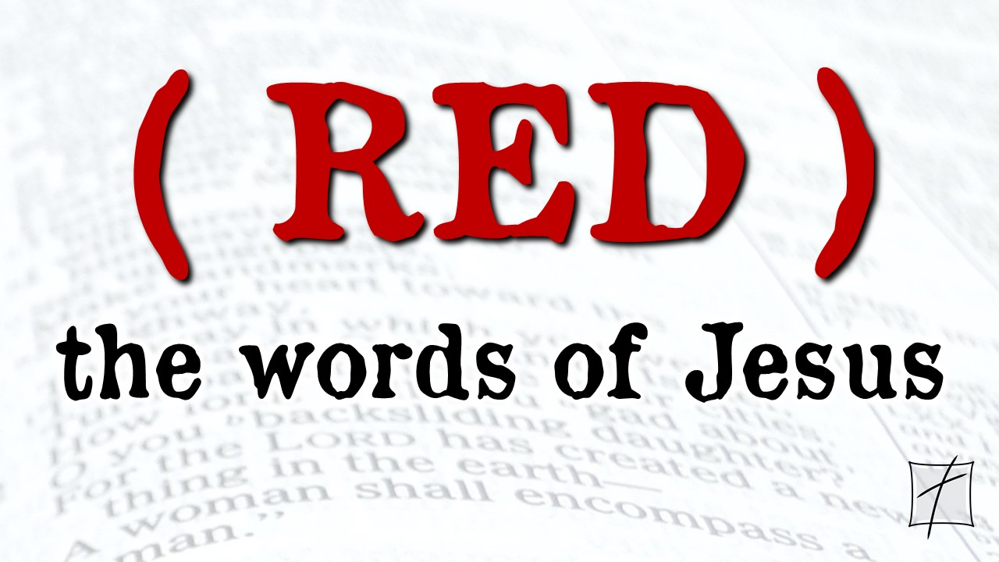November 1, 2020

Pastor Joseph Britain

 Real Government belongs to ____________

For a Child will be born to us, a Son will be given to us; And the government will rest on His shoulders; And His name will be called Wonderful Counselor, Mighty God, Eternal Father, Prince of Peace. (Is 9:6)

And Jesus came up and spoke to them, saying, “All authority in heaven and on earth has been given to Me. Go, therefore, and make disciples of all the nations, baptizing them in the name of the Father and the Son and the Holy Spirit, teaching them to follow all that I commanded you; and behold, I am with you always, to the end of the age.” (Matt 28:18-20)

Jesus answered, “My kingdom is not of this world. If My kingdom were of this world, My servants would be fighting so that I would not be handed over to the Jews; but as it is, My kingdom is not of this realm.” Therefore Pilate said to Him, “So You are a king?” Jesus answered, “You say correctly that I am a king. For this purpose I have been born, and for this I have come into the world: to testify to the truth. Everyone who is of the truth listens to My voice.” (John 18:36-37)

 Keeping a right _______________

He said to him, “See that you say nothing to anyone; but go, show yourself to the priest and offer for your cleansing what Moses commanded, as a testimony to them.”

(Mark 1:44)

But they *(the Samaritans)* did not receive Him, because His face was set for the journey to Jerusalem. And when His disciples James and John saw this, they said, “Lord, do You want us to command fire to come down from heaven and consume them, just as Elijah did?” But He turned and rebuked them, and said, “You do not know what manner of spirit you are of. For the Son of Man did not come to destroy men’s lives but to save them.” (Luke 9:53-56a NKJV)

 Vote _______________

– Vote _______________________

Do not judge by the outward appearance, but judge with righteous judgment.

(John 7:24)

 __________ your enemies

“You have heard that it was said, ‘You shall love your neighbor and hate your enemy.’ But I say to you, love your enemies and pray for those who persecute you, so that you may prove yourselves to be sons of your Father who is in heaven; for He causes His sun to rise on the evil and the good, and sends rain on the righteous and the unrighteous. For if you love those who love you, what reward do you have? Even the tax collectors, do they not do the same? And if you greet only your brothers and sisters, what more are you doing than others? Even the Gentiles, do they not do the same? Therefore you shall be perfect *(whole or complete)*, as your heavenly Father is perfect *(whole or complete)*.” (Matt 5:43-48)

Those from among you will rebuild the ancient ruins; You will raise up the age-old foundations; And you will be called the repairer of the breach, The restorer of the streets in which to dwell. (Is 58:12)

 Be about ________ business

So, when they had come together, they began asking Him, saying, “Lord, is it at this time that You are restoring the kingdom to Israel?” But He said to them, “It is not for you to know periods of time or appointed times which the Father has set by His own authority; but you will receive power when the Holy Spirit has come upon you; and you shall be My witnesses both in Jerusalem and in all Judea, and Samaria, and as far as the remotest part of the earth.” (Acts 1:6-8)

All scripture is from the New American Standard Version unless otherwise noted