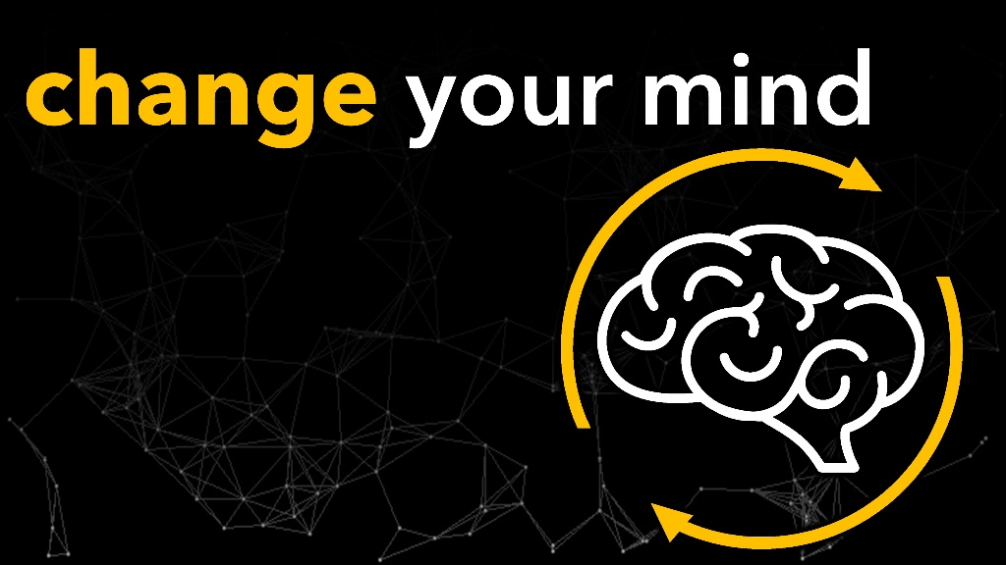

**March 23, 2022**

**Pastor Joseph Britain**

For as he thinks within himself, so he is. - Prov 23:7a



Your life moves in the ______________________

of your strongest thoughts

Set your minds on the things that are above, not on the things that are on earth

- Col 3:2



_____________ are we now?

**Worried 1 2 3 4 5 6 7 8 9 10 Peaceful**

**Negative 1 2 3 4 5 6 7 8 9 10 Positive**

**Worldly 1 2 3 4 5 6 7 8 9 10 Eternal**



You can’t have a __________________ life

with a __________________ mind



Your brain functions in __________________

Do not conform to the pattern of this world, but be transformed by the renewing of your mind - Rom 12:2 NIV



_________ your mind

Set your minds on the things that are above, not on the things that are on earth - Col 3:2

Fix your thoughts on what is true, and honorable, and right, and pure, and lovely, and admirable. Think about things that are excellent and worthy of praise. - Php 4:8b NLT

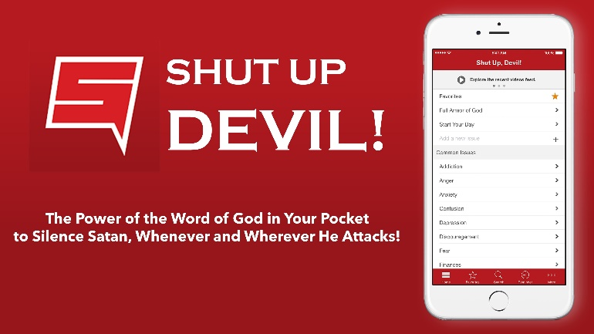

You will know the truth, and the truth will set you free - John 8:32

All scripture is from the New International Version unless otherwise noted