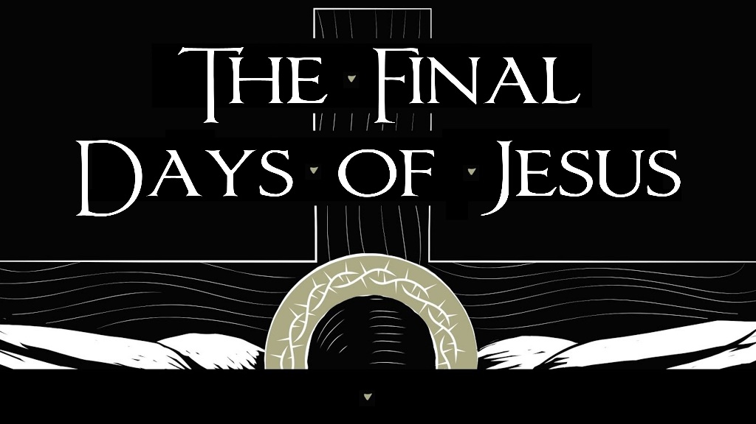

**March 27, 2022**

**Pastor Joseph Britain**



A Jewish day begins at ____________________

God called the light “day,” and the darkness He called “night.” And there was evening and there was morning, one day. – Gen 1:5



A condensed ____________________



Nothing but _______________

Now in the early morning, when He was returning to the city, He became hungry. And seeing a lone fig tree by the road, He came to it and found nothing on it except leaves alone; and He said to it, “No longer shall there ever be any fruit from you.” And at once the fig tree withered. - Matt 21:18-19



Nothing genuine, nothing __________

And He entered the temple area and began to drive out those who were selling and buying on the temple grounds, and He overturned the tables of the money changers and the seats of those who were selling doves; and He would not allow anyone to carry merchandise through the temple grounds. And He began to teach and say to them, “Is it not written: ‘My house will be called a house of prayer for all the nations’? But you have made it a den of robbers.” - Mark 11:15b-17

You hypocrites, rightly did Isaiah prophesy about you, by saying: “This people honors Me with their lips, but their heart is far away from Me.” - Matt 15:7-8



The right _____________

Jesus, knowing that the Father had handed all things over to Him, and that He had come forth from God and was going back to God, got up from supper and laid His outer garments aside; and He took a towel and tied it around Himself. Then He poured water into the basin, and began washing the disciples’ feet and wiping them with the towel which He had tied around Himself. - John 13:3-5

Don’t you know that you yourselves are God’s temple and that God’s Spirit dwells in you? - 1Cor 3:16 NIV

All scripture is from the New International Version unless otherwise noted