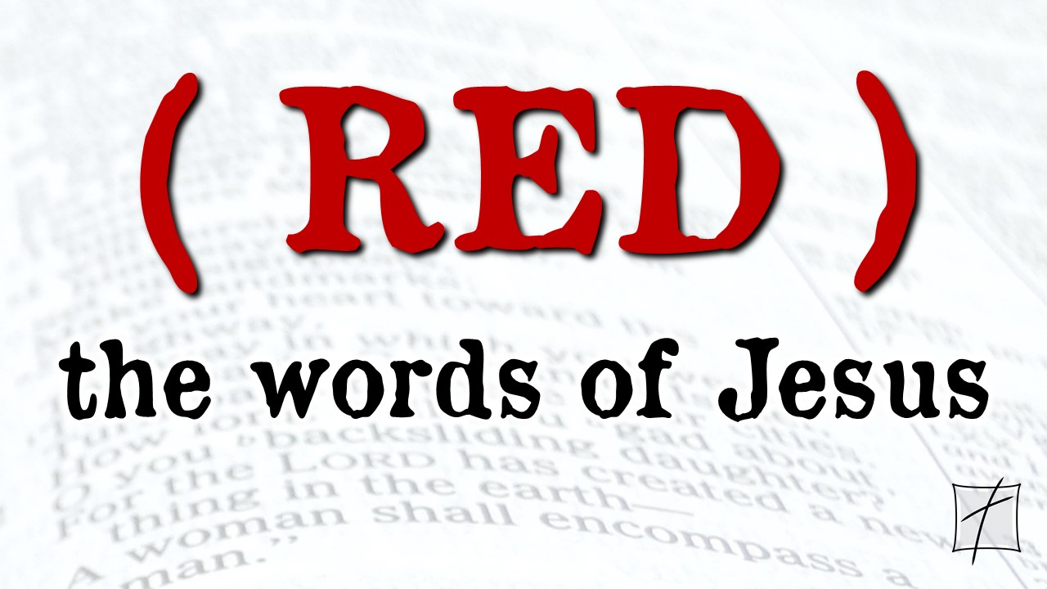October 25, 2020

Pastor Joseph Britain

Now all the tax collectors and the sinners were coming near Him to listen to Him. Both the Pharisees and the scribes began to grumble, saying, “This man receives sinners and eats with them.” (Luke 15:1-2)

“Or what woman, if she has ten silver coins and loses one coin, does not light a lamp and sweep the house and search carefully until she finds it? When she has found it, she calls together her friends and neighbors, saying, ‘Rejoice with me, for I have found the coin which I had lost!’” (Luke 15:8-9)

 The __________ and _____________ chapter

 The _____________ of a single one

Then the angel showed me Jeshua the high priest standing before the angel of the Lord. The Accuser, Satan, was there at the angel’s right hand, making accusations against Jeshua. And the Lord said to Satan, “I, the Lord, reject your accusations, Satan. Yes, the Lord, who has chosen Jerusalem, rebukes you. This man is like a burning stick that has been snatched from the fire.” Jeshua’s clothing was filthy as he stood there before the angel. So the angel said to the others standing there, “Take off his filthy clothes.” And turning to Jeshua he said, “See, I have taken away your sins, and now I am giving you these fine new clothes.” (Zech 3:1-4 NLT)

All scripture is from the New American Standard Version unless otherwise noted



****October 25, 2020

Pastor Joseph Britain

Now all the tax collectors and the sinners were coming near Him to listen to Him. Both the Pharisees and the scribes began to grumble, saying, “This man receives sinners and eats with them.” (Luke 15:1-2)

“Or what woman, if she has ten silver coins and loses one coin, does not light a lamp and sweep the house and search carefully until she finds it? When she has found it, she calls together her friends and neighbors, saying, ‘Rejoice with me, for I have found the coin which I had lost!’” (Luke 15:8-9)

 The __________ and _____________ chapter

 The _____________ of a single one

Then the angel showed me Jeshua the high priest standing before the angel of the Lord. The Accuser, Satan, was there at the angel’s right hand, making accusations against Jeshua. And the Lord said to Satan, “I, the Lord, reject your accusations, Satan. Yes, the Lord, who has chosen Jerusalem, rebukes you. This man is like a burning stick that has been snatched from the fire.” Jeshua’s clothing was filthy as he stood there before the angel. So the angel said to the others standing there, “Take off his filthy clothes.” And turning to Jeshua he said, “See, I have taken away your sins, and now I am giving you these fine new clothes.” (Zech 3:1-4 NLT)

All scripture is from the New American Standard Version unless otherwise noted