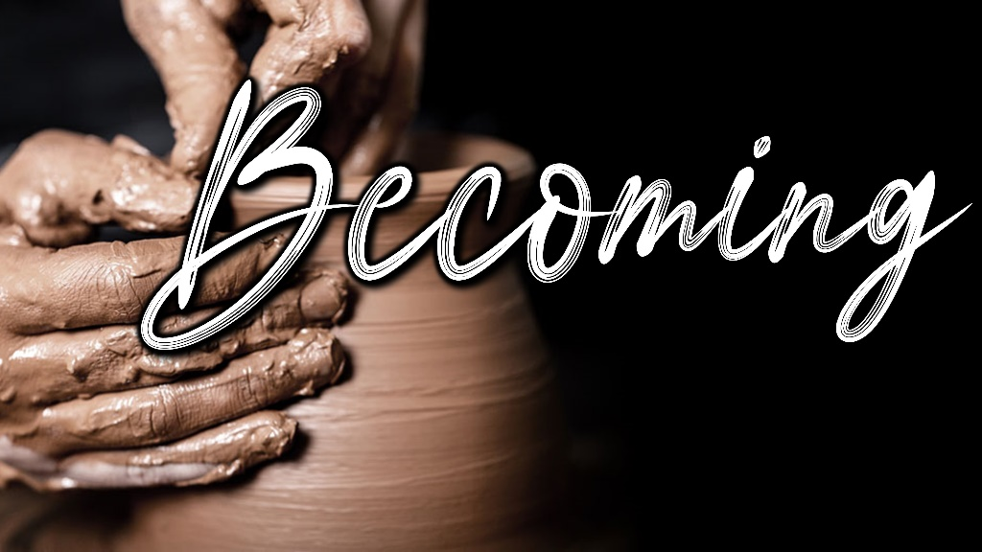

**January 9, 2022**

**Pastor Joseph Britain**

Jeremiah, go down to the potter’s house. I will give you my message there

- Jer 18:2 ERV

**Who are you becoming?**

Work out your own salvation with fear and trembling - Php 2:12b



First step – ____________

(God speaking) Before I formed you in the womb I knew you, and before you were born I consecrated you - Jer 1:5a



Second step – ______________ or ______________

My children, with whom I am again in labor until Christ is formed in you

- Gal 4:19



Third step – ____________ and ________________

Your kingdom come. Your will be done, on earth as it is in heaven - Matt 6:10

Fourth step – ______________ process

But now, Lord, You are our Father; We are the clay, and You our potter, and all of us are the work of Your hand. - Is 64:8

Sometimes… – _____________ and _____________

But the pot he was shaping from the clay was marred in his hands; so the potter formed it into another pot, shaping it as seemed best to him - Jer 18:4 NIV

**January 9, 2022**

**Pastor Joseph Britain**

Jeremiah, go down to the potter’s house. I will give you my message there

- Jer 18:2 ERV

**Who are you becoming?**

Work out your own salvation with fear and trembling - Php 2:12b



First step – ____________

(God speaking) Before I formed you in the womb I knew you, and before you were born I consecrated you - Jer 1:5a



Second step – ______________ or ______________

My children, with whom I am again in labor until Christ is formed in you

- Gal 4:19

Third step – ____________ and ________________

Your kingdom come. Your will be done, on earth as it is in heaven - Matt 6:10

Fourth step – ______________ process

But now, Lord, You are our Father; We are the clay, and You our potter, and all of us are the work of Your hand. - Is 64:8

Sometimes… – _____________ and _____________

But the pot he was shaping from the clay was marred in his hands; so the potter formed it into another pot, shaping it as seemed best to him - Jer 18:4 NIV